Treasures in Heaven

Aim: To get the children to discover what their treasure is (their own talents and gifts that they can use for Jesus, the special people in their lives that are Jesus to them)

Occasion: Ordinary 19

Scripture: Luke 12:32-40

Game: (for the older children) What was on the tray?
Preparation: On a tray, put lots of different things. Eg pencil, scissors, envelope, feathers, string, paper, etc. Also a piece of paper with ‘Your heart will always be where your treasure is”
Cover it with a cloth.
What to do: Give every child a piece of paper and a pen. Tell them that you are going to show them a tray of treasures, and that their job is to try and remember as many things that are on the tray as p oss ible. Show them the tray for two minutes, and then cover it up again.
Now give them another two minutes to write down as many things as they can.
When they have finished, find out who remembered the most, who found it hard, what items were hard to remember. See how many of them remembered the words on the card.

Game: (for the younger children) What is in the bag?
Preparation: Get a pillowcase and fill it full of ‘treasure’ (paper clips, cellotape, string, etc) You also need a list (that only you can see) of all the things.
What to do: Get each child to put their hands in the pillowcase and without taking anything out, get them to guess what one of the items in the bag is. If they guess right, tick the item off the list.
Either see how long it takes them to guess everything. Or let everyone have one turn, and then tip out the contents to find out what they missed out.

Story: (Luke 12:32-40, adapted) Treasures in Heaven
Once again, Jesus was talking to his disciples to encourage them.
He said: Don’t be afraid! God wants to give you the Kingdom!
Sell everything you have and give the money to people who need it more than you. Make yourselves moneybags that will never wear out.
You need to make sure that your treasure is safe in heaven, where thieves cannot steal it and moths cannot destroy it, because your heart will always be where your treasure is.
Be ready like children who wait for their friends to come over for a visit.
As soon as they arrive, the children open the door and let their friends in and make their friend feel really welcome.
Be ready always, because you never know when the Son of God will come to visit.

Questions:
- What is important to you, what do you treasure?
- How do you look after what you treasure?
- What does Jesus want us to treasure?

Activity: Activity: Treasure box/bag
(Make hearts/coins and write on them the things that are special to you)
ordinary-sunday-19-wksht.gif(17.60 KB)
What you need: material, double sided tape, ribbon or string, treasure bag template, treasure coins template, things to decorate with.
What to do:

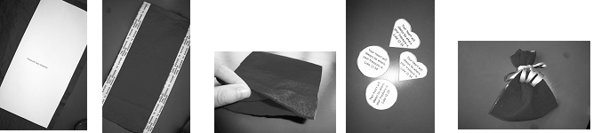

To make the bag:
Using the treasure bag template, trace around the template onto a piece of material.
Cut out the material.
Stick a piece of double sided tape down the two long sides of the material and peel off the backing from the tape.
Fold the material in half.
To make the coins:
Give each child a lot of treasure coin templates. Get them to write or draw on the back of each coin, what the treasure. E.g. friends, family, things about themselves that they like. Try to encourage them not to write down things.

How to use: Get the children to gather after the activity and to sit in a circle. Get them to one at a time place their treasure in the centre. When they all have, say a prayer offering all these good treasures up to God.
When the children take them home, encourage them to pray for or add to their treasures.

