 Stop and pray for...

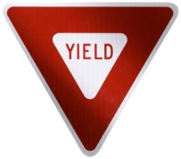 For good relationships with others

C:\Users\Julie Hintz\AppData\Local\Microsoft\Windows\Temporary Internet Files\Low\Content.IE5\XPPN7F7O\MC900411364[1].WMF For people on a rough or bumpy road

C:\Users\Julie Hintz\AppData\Local\Microsoft\Windows\Temporary Internet Files\Low\Content.IE5\S05N2X4Y\MC900054581[1].WMF For children and families

C:\Users\Julie Hintz\AppData\Local\Microsoft\Windows\Temporary Internet Files\Low\Content.IE5\D54J19RC\MC900030251[1].WMF For people in dangerous situations

C:\Users\Julie Hintz\AppData\Local\Microsoft\Windows\Temporary Internet Files\Low\Content.IE5\4N87V9LQ\MC900036663[1].WMF For the week ahead

 For our pets and animals around the world