A man with Demons in him

Aim: To teach the children to ask for help when they are in trouble. And remind them that they are special to God

Occasion: Ordinary 12

Scripture: Luke 8:26-39

Game: (for the older children) Peg Game
What you need: lots of pegs
What to do: give each of the children 4 pegs. Get them to attach them to their clothing, in places that they can be seen and that they are comfortable with people grabbing at.
Next tell them that when you say 'go!', they have 2 minutes to get as many pegs as they can.
However, they can only grab one peg at a time and they must attach the peg to their own self before they can get another.
After the two minutes is up, get the children to tell you how many pegs they have. See who has the most.
If you have time, play another round.

Game: (for the younger children) I like…
What to do: Get the children to sit in a circle. Ask for a volunteer. The volunteer stands in the middle of the circle, and starts the game by saying 'I am (name) and I like …' (Get the volunteer to say something they like eg the colour red, drawing, teletubbies etc)
All the children that also like that thing, have to get up and switch seats with someone else including the volunteer. The child that is last stands in the middle and gets to say 'I am (name) and I like…'

Story: A man with Demons in him Luke 8:26 -39
Jesus and his disciples sailed across Lake Galilee and came to shore near the town of Gerasa. As Jesus was getting out of the boat, he was met by a man from that town. The man had demons in him. He had gone without clothes for a long time and didn't live in a house. The man saw Jesus and screamed.
He knelt down in front of him and shouted, "Jesus, Son of God in heaven, what do you want with me? I beg you not to torture me!" He said this because Jesus had already told the evil spirit to go out of him.
The man had often been attacked by the demon. And even though he had been bound with chains and leg irons and kept under guard, the demon made the man smash whatever bound him. Then the demon would make him go where he didn't want to go.
³⁰Jesus asked the man, "What is your name?"
He answered, "My name is Lots." He said this because there were `lots' of demons in him.
The demons begged Jesus not to send them to the deep pit, where they would be punished. A large herd of pigs was feeding there on the hillside. So the demons begged Jesus to let them go into the pigs, and Jesus let them go. Then the demons left the man and went into the pigs. The whole herd rushed down the steep bank into the lake and drowned.
When the men taking care of the pigs saw this, they ran to spread the news in the town and on the farms. The people went out to see what had happened, and when they came to Jesus, they also found the man. The demons had gone out of him, and he was sitting there at the feet of Jesus. He had clothes on and was in his right mind. But the people were terrified.
Then all who had seen the man healed told about it. Everyone from around Gerasa begged Jesus to leave, because they were so frightened. When Jesus got into the boat to start back, the man who had been healed begged to go with him. But Jesus sent him off and said, "Go back home and tell everyone how much God has done for you." The man then went all over town, telling everything that Jesus had done for him.

Talk: Has there ever been a time when you have had people teasing you or making you do things that you didn't want to do? (Pause for answers). It's not very nice is it? Well, in today's story, we heard about a man called Lot that had been bullied by some not so nice demons. They were picking on him and wouldn't leave him alone. How does it make you feel when someone is mean to you? (Pause) Well, I think that is how Lot felt too.
When people pick on you all the time, it makes you feel bad about yourself and makes it hard to do anything else, and you start to feel bad about yourself too.
But God created all of us in God's own image, and God is Love so we must be loved by God too!
So, what did Lot do in the story that made the demons go away? (Pause). That's right, he asked for Jesus' help, and Jesus helped him by making the demons go away!
So, what are some things that we can do if we are being picked on and made to feel bad about ourselves? (Pause) Well, we can ask for help from someone older that we trust, like a parent or teacher. We can also pray.
Well today we are going to make 'God made me special' cards to remind ourselves what is cool and unique about us!
Questions:
- Have you ever been teased or been made to do things that you didn't want to?
- How did it make you feel?
- How do you think Lot was feeling about being picked on?
- How does Jesus feel about us?
- What can you do if someone is picking on you?

Activity: God made me special cards!
What you need: a template for each child, scraps of material, wool, magazines, glitter, etc for decorating, card, pens, scissors and glue
What to do:
Give each child a piece of card and a template. (There is a girl and a boy template to choose from.)
Fold the piece of card in half.
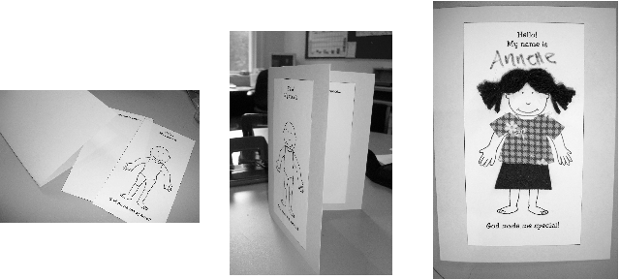
On the cover, glue the template 'Hello! My name is'
On the inside right side, glue the template 'I am special because…'
Decorate the person on the front to look like you.
Write your name at the top.
On the inside, write or draw things that make you special.
E.g. I can play the piano. I have a nice laugh. I am good to my friends. Etc

Variations: (for the older children) you might like to write the names of each of the children on an envelope. Then get the children to write down one thing they like about everyone else in the group and stick the paper in the corresponding envelope.
At the end of the session, you can give each child the envelope with their name in to put inside their 'God made me special' cards.
