The Ascension of Jesus

Aim: To talk to the children about Jesus’ Ascension: what it was and what it meant

Occasion: Ascension Day

Scripture: Luke 24:44-53

Game: Clumps
What to do: Get the children to walk around the room saying ‘mumble mumble’. Tell them that when you call out a number, they have to get into groups of that number. If there are left over children, they form a group with who’s left. Once in their group, get them to ask each other something. Eg ‘Find out what colour toothbrush all the people in your group have.’ When they have, get them to walk around again saying ‘mumble mumble!’ And repeat.
Variation:
Instead of just walking around, get them to do different things eg run, crawl, skip, jump etc
Instead of asking questions in their groups, get them to create a human statue of different things you call out. Eg spaghetti on toast, a washing machine etc

Story: The Ascension of Jesus (Luke: 24:44-53)
Note: If you would like to tell the story with visuals, then enlarge on the photocopier each of the boxes from the activity, and use them. Then each time you get to a disciple picture, ask one of the children to draw how they thing the disciples are feeling. Eg happy = smiley mouth!
Setting the scene: Jesus was crucified and had risen from the dead just as he said he would! He had also appeared to lots of people since then to show them that he was still alive.
We now join Jesus and his disciples as he appears to them for the last time before he returns to God in heaven...
Jesus told them ‘Before I died, I told you that everything written in the Law of Moses, the book of Prophets and in the Psalms had to happen.’
‘We sort of remember’ thought the disciples
Jesus helped the Disciples by explaining the scriptures.
‘Now we will remember’ thought the disciples
Jesus told them ‘the scriptures say that the messiah must suffer, then three days later, rise from death’
‘That has happened!’ thought the disciples
Jesus told them ‘the scriptures say all people in the world must be told about God so that they too can be forgiven’
‘That hasn’t happened yet!’ thought the disciples
Jesus told them ‘so beginning in Jerusalem, you must tell everything that has happened’
‘That’s a bit scary!’ thought the disciples
Jesus told them ‘I will send you the holy spirit as God promised to help you, but you must wait in the city until it comes’
‘That will make it easier!’ thought the disciples
Jesus took the disciples to Bethany, raised his hands, and blessed them.
‘Wow!’ thought the disciples
Jesus was then taken up to heaven.
‘Let’s Worship Jesus!’ thought the disciples, and they did!

Questions:
- What do you think ascension means? (basically it’s the day that Jesus ‘ascended’ or ‘went up’ to heaven.)
- How would you have felt if you had been one of the disciples in the story?
- What do you think Jesus being taken up to heaven would look like?

Activity: your own book of scriptures!

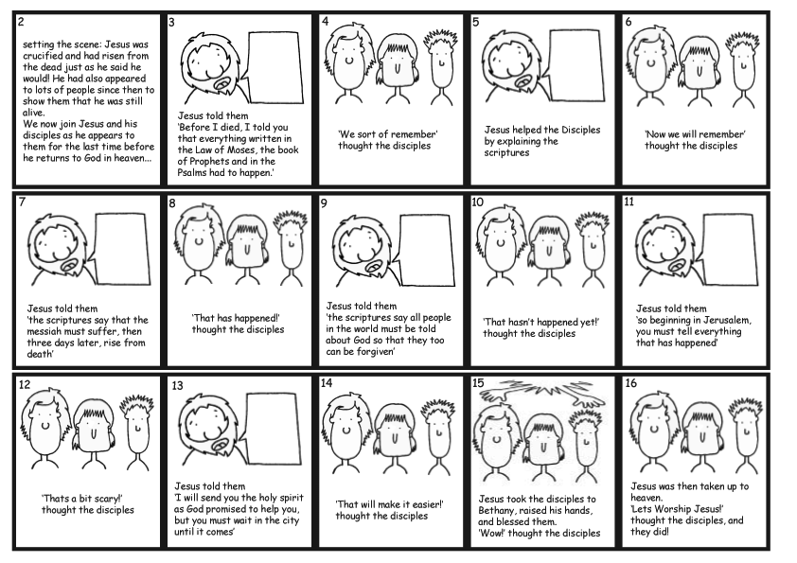
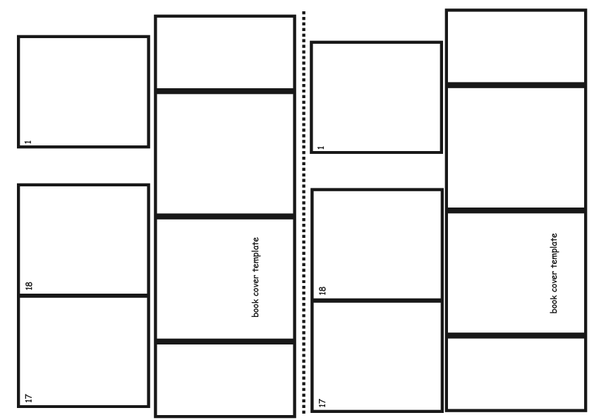
You will need: Card, paper, glue sticks and felts/crayons/etc to decorate and the templates!
Preparation: for the younger children, you might like to pre-make the book covers
What to do: Give each child a copy of all the templates. Cut out the pieces as shown in the first photo
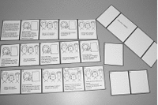
Tape the story into one long piece. Use the page numbers in the top left-hand corner as a guide.
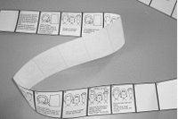
Fold the story up like a fan as shown.

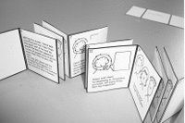
Glue the book cover template to a piece of card and then cut out. Cut as one piece, not as four!
Fold along the black lines as shown
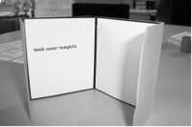
Tape the flaps down as shown. They will form pockets for the story
Slide the first and last pages into the book cover pockets.
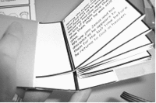
It is now finished. Decorate, and don’t forget to fill in the expressions of the disciples!

